**DAILY ONLINE ACTIVITIES SUMMARY**

|  |  |  |  |  |  |  |  |  |
| --- | --- | --- | --- | --- | --- | --- | --- | --- |
| **Date:** | 05-06-2020 | | | | | **Name:** | Anvitha H M | |
| **Sem & Sec** | 4th ‘A’ | | | | | **USN:** | 4AL18CS010 | |
| **Online Test Summary** | | | | | | | | |
| **Subject** | | N/A | | | | | | |
| **Max. Marks** | | N/A | | **Score** | | | N/A | |
| **Certification Course Summary** | | | | | | | | |
| **Course** | Introduction to cyber security. | | | | | | | |
| **Certificate Provider** | | | Great learning academy | | **Duration** | | | 7 hour |
| **Coding Challenges** | | | | | | | | |
| **Problem Statement:**  Program to find the repeated character in a string. | | | | | | | | |
| **Status:** Executed | | | | | | | | |
| **Uploaded the report in Github** | | | | | YES | | | |
| **If yes Repository name** | | | | | <https://github.com/anvithahm/LOCKdown-coding> | | | |
| **Uploaded the report in slack** | | | | | Yes | | | |

**Online test:** N/A

**Certification course:**

Introduction to cyber security:

The rest course included introduction to cryptography, secure system design, threats and vulnerabilities of the cyber security with some assignments and quiz of it.

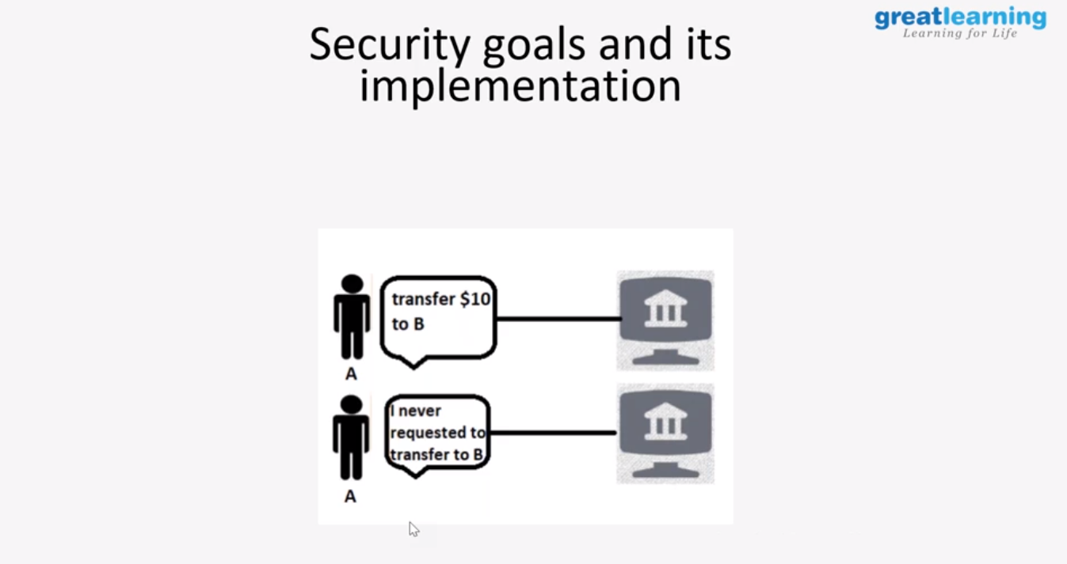

Online coding challenge

The programing statements of the day is “program to find repeat characters in string”.

Solution: Executed and uploaded in Github repository.

Link: <https://github.com/anvithahm/LOCKdown-coding>

